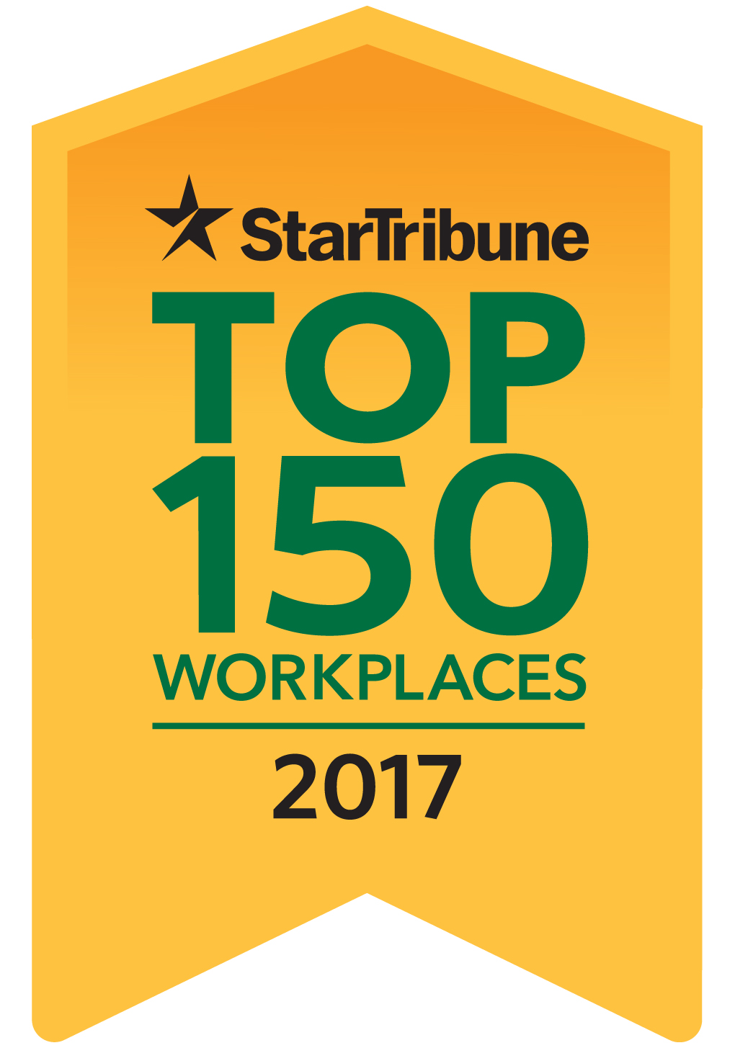

I am delighted to let you know that [your company’s name] has received the special recognition of being named a Top 150 Workplace—a ranking that places us among the best of the best.

On the afternoon of Wednesday, June 21 you will be able to see us named on StarTribune.com/topworkplaces2017, and on Sunday, June 25, we will be listed in the
Star Tribune special section “Top Workplaces 2017.”

The evaluation for the Top Workplaces program is based upon feedback from an employee survey that many of you completed a few months ago. We had [your company’s number of responses] to the survey, so thank you all for taking the time to respond.

Over 2,000 organizations were invited to participate in the survey, and over 69,000 employees shared their views. We are honored to be included in the list of Top Workplaces. Especially since the judges were you, our employees!

