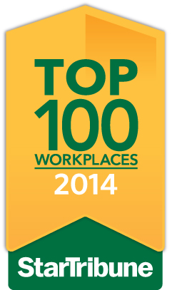

On Sunday, June 15, the Star Tribune is publishing “Top Workplaces 2014”—
a list of the best places to work in Minnesota. I am delighted to let you know that has received the special recognition of being named a Top 100 Company—a ranking that places us among the best of the best. On Sunday, June 15, you will be able to see us named in a special section of the Star Tribune and at StarTribune.com/topworkplaces2014.

The evaluation for the Top Workplaces program is based upon feedback from an employee survey that many of you completed a few months ago. We had responses to the survey, so thank you all for taking the time to respond.

Over 2,000 organizations were invited to participate in the survey, and over 58,600 employees shared their views. We are honored to be included in the Top 100. Especially since the judges were you, our employees!

